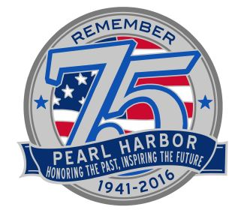
June 16, 2016
For immediate release

Pearl Harbor commemoration will recognize AJA veterans
December’s 75th commemoration of the attack on Pearl Harbor will include a tribute to the Americans of Japanese ancestry who served the United States in World War II. Entitled “Fighting Two Wars: Japanese American Veterans Tribute,” the luncheon will be held from 11 a.m. to 2 p.m. at Hilton Hawaiian Village on Monday, December 5.
All World War II veterans of the 100th Infantry Battalion, Military Intelligence Service, 442nd Regimental Combat Team and 1399th Engineer Construction Battalion are encouraged to attend. The event is being organized by the 75th Commemoration of Pearl Harbor Committee, in cooperation with those units’ veterans clubs.
Each veteran and a companion will be able to attend free of charge, but reservations must be made in advance through the respective veterans clubs. Others will able to purchase tickets. If you plan to attend, please contact the Hawaii veterans clubs of the 100th, 442nd or MIS or the Nisei Veterans Legacy Center, P.O. Box 2476, Honolulu, HI 96804; phone (808) 971-1060, e-mail inquire@nvlchawaii.org
Admiral Harry B. Harris Jr., commander of the U.S. Pacific Command, will be the keynote speaker. Harris’s father and uncles served in the U.S. Navy in World War II. His mother grew up in Japan. Today, Harris is the top-ranking U.S. defense official in the Pacific and Asia.
The December 5 luncheon is one of the signature events of the 11-day observance of the Japanese attack on military bases on O‘ahu on December 7, 1941. Survivors of the attack are invited to participate in the many events that make up this commemoration.
Those survivors include not only military personnel from the Mainland, but also thousands of Hawai‘i residents who were in the military and many more civilians who were on O‘ahu that day. All of them have stories that are worth remembering this year with the 75th commemoration, whose theme is “Honoring the past, inspiring the future.”
Information about the December 5 tribute and other events of the 75th commemoration is available at http://www.pearlharbor75thanniversary.com/

